Chandigarh Engineering College Jhanjeri
Mohali-140307

Department of Computer Science & Engineering

Mid Term Report
on
E-Commerce Product Search

Project-I

BACHELOR OF TECHNOLOGY
(Computer Science and Engineering)


SUBMITTED BY:
Mukul Anand (2330155)
Piyush Raj (2330169)
Pawan Kumar Sharma (2330166)
Pardeep (2330165)
April 2025

Under the Guidance of
Dr. Ishu Sharma
Associate professor

Department of Computer Science & Engineering
Chandigarh Engineering College
Jhanjeri, Mohali-140307

Chandigarh Engineering College Jhanjeri
Mohali-140307
Department of Computer Science & Engineering

Table of Contents
S.  No. | Contents | Page No
1. | Introduction | 1-2
2. | System Requirements | 2
3. | Software Requirement Analysis | 2-3
4. | Software Design | 4
5. | Implementation | 13

1. Introduction
Product search is a core feature of modern e-commerce platforms, helping users find relevant items quickly and efficiently. This project focuses on building a responsive and user-friendly e-commerce product search system that enhances the shopping experience through smooth navigation and filtering.
In this application, users are presented with a wide range of products and can use a dynamic search bar to filter results based on keywords, categories, or price range. The interface is designed to be intuitive, ensuring that users can find desired products with minimal effort.
This project not only improves web development skills but also deepens the understanding of search logic, user experience design, and front-end optimization in an engaging and practical context.

1.1 Facilities Required for Proposed Work
To develop the E-Commerce Product Search system, the following facilities and resources are required:

Hardware Requirements
  - computer or laptop with a standard processor and RAM for frontend development and testing.
• Internet connectivity for accessing libraries, hosting platforms, and debugging tools
  - Software & Development Tools (Web-Based)
• Programming Languages: HTML, CSS, JavaScript (ES6+) for building the UI and dynamic search .
• Frameworks/Libraries: Bootstrap for responsive design; optional use of jQuery for DOM manipulation.
• Backend & Database: (Optional) Firebase or localStorage for handling cart data and user sessions.
• Development Tools: VS Code for coding, Chrome DevTools for testing and debugging, GitHub for version control.
• Deployment: Netlify or GitHub Pages for hosting the website.
- Data Resources:
  - Product Dataset: Static or dynamic JSON files containing product details like name, price, and category.
• Search Data: Keywords entered by users, filter preferences, and category selections.
• Cart Data: Stores items added to cart, quantity, and total pricing logic.

1.2 Objectives
• Simplify Product Discovery – Allow users to easily search and find relevant products using keywords.
- • Improve User Experience – Ensure smooth and responsive design for better navigation and accessibility.
• Enable Real-Time Filtering – Provide dynamic product filtering based on categories, price, and keywords.
• Develop Frontend Skills – Strengthen HTML, CSS, and JavaScript knowledge through hands-on development.
• Enhance Engagement – Make the interface visually appealing and interactive for a better shopping experience.

2. System Requirements
To develop the E-Commerce Product Search system, the following facilities and resources are required:

2.1 Hardware Requirements
• A computer or laptop with a standard processor and sufficient RAM for development and testing.
• Stable internet connection for accessing libraries, hosting platforms, and online resources.
• 2.2 Software & Development Tools (Web-Based)
• Programming Languages: HTML, CSS, JavaScript (ES6+) for front-end structure and interactivity.
• Frameworks/Libraries: Bootstrap for responsive design; optional use of jQuery or vanilla JS enhancements.
• Backend & Database: Optional use of Firebase or localStorage for handling user sessions and cart data.
• Development Tools: VS Code for code writing, Chrome DevTools for debugging, GitHub for version control.
• Deployment: Netlify or GitHub Pages for hosting the web-based application.

3. Software Requirement Analysis

3.1 Programming Languages
3.1.1 HTML, CSS, JavaScript
o Purpose: Used for creating the structure, styling, and interactive features of the e-commerce website.
- Justification:
  - HTML structures the content and layout of the product listings and other sections.
• CSS enhances the visual presentation with layout design, colors, fonts, and responsiveness.
• JavaScript (ES6+) handles dynamic search, product filtering, and interactive cart functionalities.
3.2 Backend & Database
3.2.1 Not Applicable
o Purpose: This project does not use any backend or external database.
o Justification:
• All data such as product details and cart information is handled through JavaScript using local data (JSON or arrays).
• Simplifies development and deployment by keeping the project frontend-only.

3.3 Development Tools
  - 3.3.1 VS Code
- Purpose: Integrated Development Environment (IDE) for writing and organizing code.
- Justification:
- User-friendly and supports syntax highlighting, live server, and extensions for frontend development.
• Enables efficient development and debugging with integrated tools.
- 3.3.2 Chrome DevTools
Purpose: Debugging, testing responsiveness, and analyzing website performance.
Justification:
• Provides real-time inspection of HTML, CSS, and JavaScript code.
• Helps identify layout issues and optimize page load and interactivity.
- 3.3.3 GitHub (Optional)
Purpose: Version control and online repository management.
Justification:
• Allows code backup, progress tracking, and optional team collaboration.
• Enables easy integration with hosting platforms like Netlify.
3.4 Deployment
3.4.1 Netlify or GitHub Pages
Purpose: Hosting the responsive e-commerce web application.
Justification:
• Simple deployment process directly from a GitHub repository.
• Fast, free, and reliable hosting for static frontend websites.

3.5 Deployment
3.5.1 Netlify or GitHub Pages
Purpose: Hosting the responsive e-commerce website for public access.
Justification:
• Provides easy and free deployment for static websites built with HTML, CSS, and JavaScript.
• Allows integration with GitHub for automatic updates on every code push.
• Optimized for fast loading, responsive design, and user-friendly performance on all devices.

4. Software Design
4. Software Design
In designing the E-Commerce Product Search system, it is essential to understand how users interact with the website, how product data is displayed and filtered, and how the cart operates. A Data Flow Diagram (DFD) helps visualize these interactions, ensuring that each component works smoothly before starting the implementation phase.
Level 0 DFD
The Level 0 DFD gives a high-level overview of how users interact with the product search system:
• External Entity: User
The User browses through the product listings, applies search filters, and adds items to the cart.
• Process: Product Search System
This process handles everything—from displaying products to filtering, searching, and managing the cart.
• Data Flows
- Product Data: The system loads and displays product details from a local dataset.
- User Search Input: The user enters keywords or selects categories.
- Filtered Results: The system dynamically updates the display based on the search/filter.
- Cart Actions: The user adds or removes items, and the cart gets updated accordingly.
Fig. 4.1 Level 0 DFD
Level 1 DFD
Breaking down the system into smaller functions helps in understanding the flow of data and interaction:
Processes
- Load Product List
• Inputs: Local product data (JSON/array).
• Actions: Loads and displays all products on page load.
• Outputs: Product grid displayed to the User.
- Search & Filter Products
• Inputs: Keywords, category, or price range from the User.
• Actions: Filters product list using JavaScript functions.
• Outputs: Filtered product grid on the screen.
- Manage Cart
• Inputs: Selected product from the User.
• Actions: Adds or removes the product from the cart. Updates quantity and total price.
• Outputs: Updated cart sidebar with real-time changes.
- Store Cart Data (Optional)
• Inputs: Current cart state.
• Actions: Stores data temporarily using JavaScript (localStorage).
• Outputs: Cart persists on page reload.
Fig. 4.2 Level 1 DFD
Data Stores
• Product Data Store: Contains product details like name, price, image, and category.
• Cart Data Store (localStorage): Holds selected items, quantity, and total for session persistence.
Data Flows
• Product Data → Process 1 → Displayed Products → User
• User Search/Filter → Process 2 → Filtered List → User
• Cart Actions → Process 3 → Updated Cart → User
• Cart Items → localStorage → Reloaded Cart Data
By designing this DFD, we ensure a clear path for how user input drives updates in the system. It clarifies responsibilities like loading data, filtering, and managing cart functionality. This layout helps keep the code modular, scalable, and easy to maintain as new features are added.

5. Implementation
In this section of the mid-term report, you’ll describe how the game is built using HTML, CSS, and JavaScript. You can structure it as follows:[13]

HTML (index.html)
<!DOCTYPE html>
<html lang="en">
<head>
<meta charset="UTF-8">
<title>Responsive E-Commerce Site</title>
<link rel="stylesheet" href="css/style.css">
</head>
<body>
<!-- Navbar -->
<div class="navbar">
<div class="logo"><img src="images/logo.png" width="125px"></div>
<nav>
<ul id="MenuItems">
<li><a href="#">Home</a></li>
<li><a href="#">Products</a></li>
<li><a href="#">About</a></li>
</ul>
</nav>
<img src="images/cart.png" width="30px" height="30px">
</div>
<!-- Hero Section -->
<div class="row">
<div class="col-2">
<h1>Give Your Workout A New Style!</h1>
<a href="#" class="btn">Explore Now →</a>
</div>
<div class="col-2">
<img src="images/image1.png">
</div>
</div>
<!-- Featured Products -->
<h2 class="title">Featured Products</h2>
<div class="row">
<div class="col-4">
<img src="images/product-1.jpg">
<h4>Red Printed T-Shirt</h4>
<p>$50.00</p>
<button class="add-to-cart">Add to Cart</button>
</div>
<!-- Add more products similarly -->
</div>
<!-- Testimonial -->
<div class="testimonial">
<div class="col-3">
<p>"Great product! Highly recommend."</p>
<img src="images/user-1.png">
<h3>Lusy</h3>
</div>
</div>
</body>
</html>
CSS (styles.css)
* {
margin: 0;
padding: 0;
box-sizing: border-box;
}
body {
font-family: 'Poppins', sans-serif;
}
.navbar, .row {
display: flex;
align-items: center;
justify-content: space-between;
}
nav ul {
list-style: none;
text-align: right;
}
nav ul li {
display: inline-block;
margin-right: 20px;
}
a {
text-decoration: none;
color: #555;
}
.container {
max-width: 1080px;
margin: auto;
padding: 0 25px;
}
.col-2, .col-3, .col-4, .col-5 {
flex-basis: 25%;
margin-bottom: 30px;
}
.btn {
background: #ff523b;
color: #fff;
padding: 8px 30px;
border-radius: 30px;
}
.btn:hover {
background: #563434;
}
.offer, .header {
background: radial-gradient(#fff, #ffd6d6);
}
.testimonial .col-3 {
text-align: center;
padding: 40px;
box-shadow: 0 0 20px rgba(0,0,0,0.1);
}
.footer {
background: #000;
color: #8a8a8a;
padding: 60px 0 20px;
}
.footer h3, .footer-col-2 img {
color: #fff;
width: 180px;
}
.products {
display: flex;
flex-wrap: wrap;
gap: 30px;
justify-content: center;
}
.product {
padding: 20px;
border: 1px solid #ddd;
border-radius: 8px;
text-align: center;
transition: transform 0.3s ease;
}
.product:hover {
transform: scale(1.05);
}
.add-to-cart {
background: teal;
color: white;
padding: 10px 20px;
border-radius: 6px;
}
body.dark-mode {
background: #121212;
color: #f1f1f1;
}
#dark-mode-toggle {
position: fixed;
top: 20px;
right: 20px;
background: #333;
color: #fff;
}
.fade-in {
opacity: 1;
transform: translateY(0);
transition: opacity 1s, transform 1s;
}
.animate {
opacity: 0;
transform: translateY(50px);
}
.cart-sidebar {
position: fixed;
top: 0;
right: 0;
background: #fff;
height: 100vh;
overflow-y: auto;
}
:root {
--primary-color: #ff523b;
--text-color: #555;
}

JavaScript (script.js)
let score = 0;
let timeLeft = 30;
let timerInterval;
const gridContainer = document.getElementById('grid');
const scoreDisplay = document.getElementById('score');
const timerDisplay = document.getElementById('timer');
const startButton = document.getElementById('startButton');
// Prime check
function isPrime(num) {
if (num <= 1) return false;
for (let i = 2; i <= Math.sqrt(num); i++)
if (num % i === 0) return false;
return true;
}

// Generate grid
function generateGrid() {
gridContainer.innerHTML = '';
const maxNumber = { easy: 100, medium: 250, hard: 500 }[localStorage.getItem('selectedLevel')] || 100;
for (let i = 0; i < 25; i++) {
const num = Math.floor(Math.random() * maxNumber) + 1;
const div = document.createElement('div');
div.classList.add('grid-item');
div.textContent = num;
div.onclick = () => checkNumber(num, div);
gridContainer.appendChild(div);
}
}
// Check number
function checkNumber(num, element) {
if (isPrime(num)) {
score += 10;
element.style.backgroundColor = 'green';
} else {
score -= 5;
element.style.backgroundColor = 'red';
}
scoreDisplay.textContent = `Score: ${score}`;
}

// Start game
function startGame() {
score = 0;
timeLeft = 30;
scoreDisplay.textContent = `Score: ${score}`;
timerDisplay.textContent = `Time Left: ${timeLeft}s`;
generateGrid();
timerInterval = setInterval(() => {
timeLeft--;
timerDisplay.textContent = `Time Left: ${timeLeft}s`;
if (timeLeft <= 0) {
clearInterval(timerInterval);
alert('Game Over! Your score is ' + score);
resetGame();
}
}, 1000);
}
// Reset game
function resetGame() {
clearInterval(timerInterval);
startButton.textContent = 'Restart Game';
startButton.onclick = () => location.reload();
}

How to Run the Code
- Create three files: index.html, styles.css, and script.js.
- Copy the respective code into each file.
- Open index.html in a web browser.

OUTPUT :-
Step 1. Click on the "Add to Cart" button to add a product.
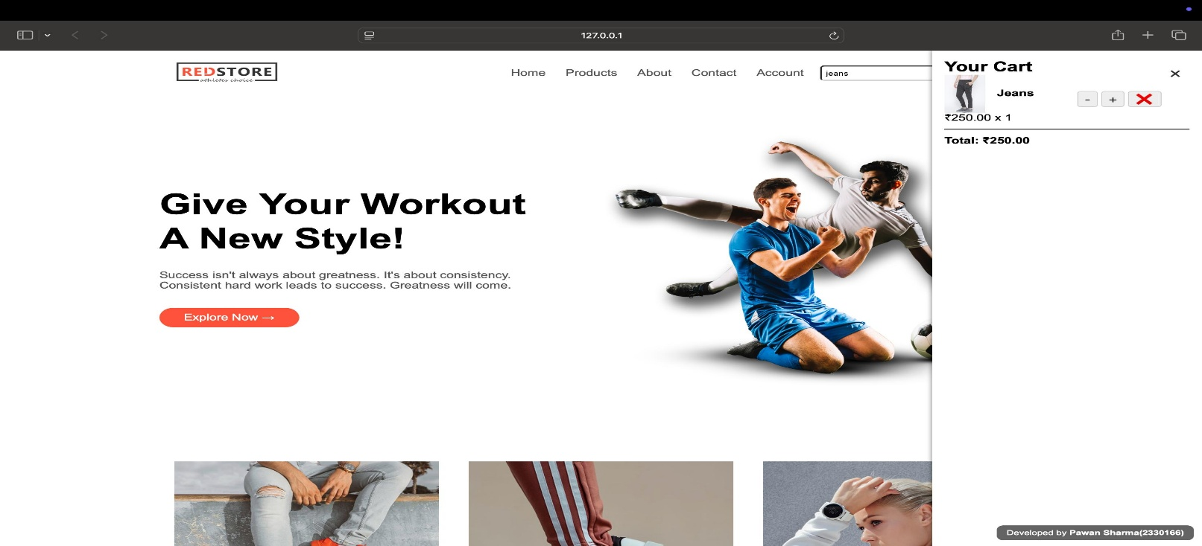

Fig. 6.1 Add to Cart Button
Step 2. Selected product will appear in the cart sidebar with quantity and price details
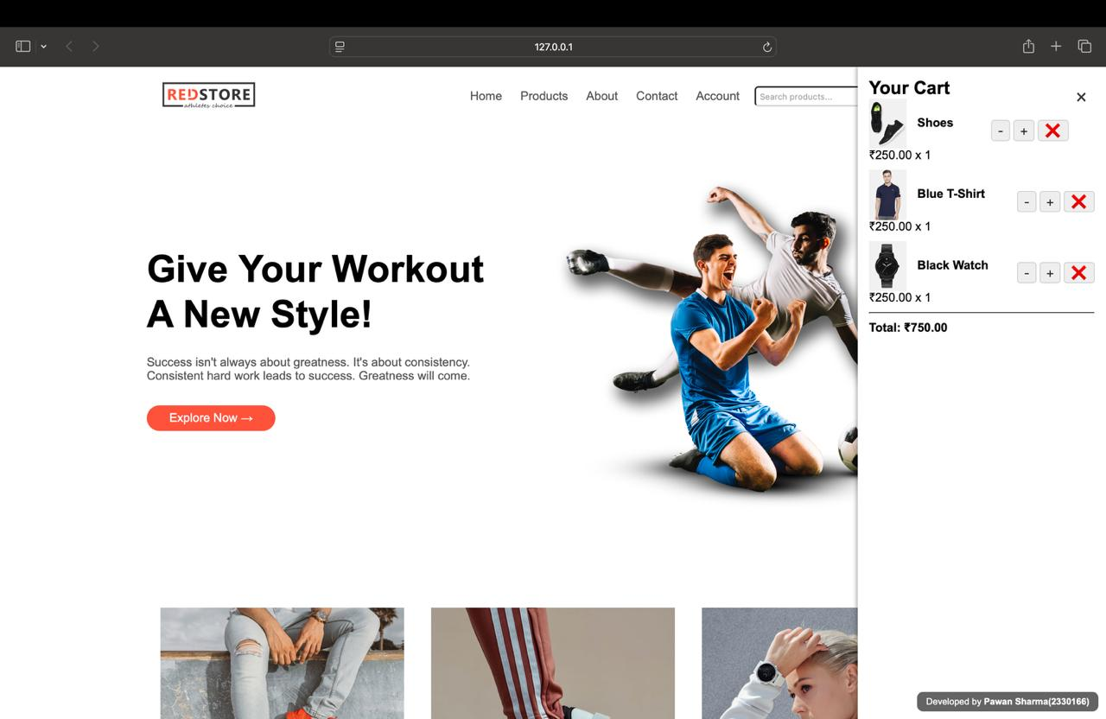
Fig. 6.2 Cart Sidebar Display
If you add multiple items, total price updates automatically. You can increase or decrease quantity using buttons..

Step 3. Search for any product using the search bar.
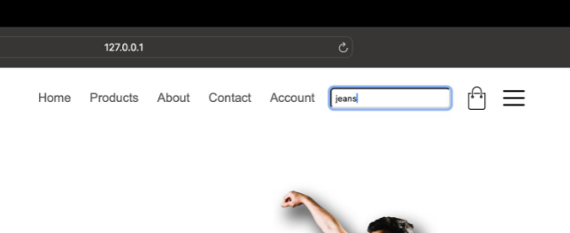
Fig. 6.3 Product Search Result

Step 4. Final step shows your selected items with total cost.

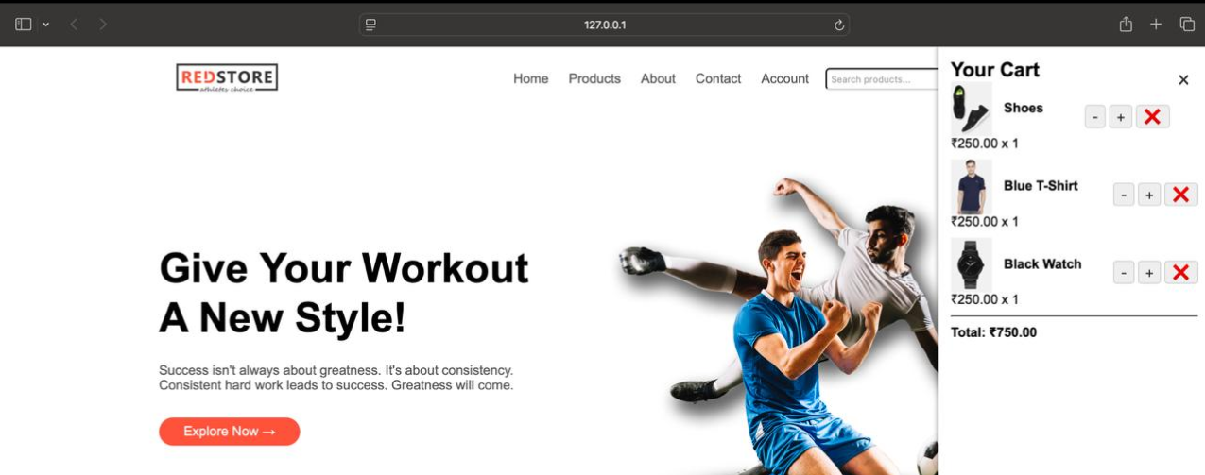

Fig. 6.4 Final Cart and Checkout Option

REFERENCES
- Dholakia, R. R., & Zhao, M. (2010). Effects of online store attributes on customer satisfaction and repurchase intentions. International Journal of Retail & Distribution Management, 38(7), 482–496.
- Laudon, K. C., & Traver, C. G. (2021). E-Commerce 2021: Business, Technology and Society (16th ed.). Pearson Education.
- Chaffey, D. (2015). Digital Business and E-Commerce Management: Strategy, Implementation and Practice (6th ed.). Pearson Education Limited.
- Turban, E., King, D., Lee, J. K., Liang, T. P., & Turban, D. C. (2015). Electronic Commerce: A Managerial and Social Networks Perspective (8th ed.). Springer.
- McKinsey & Company. (2022). The future of e-commerce: How the pandemic pushed businesses to go digital. Retrieved from https://www.mckinsey.com/
- Statista. (2023). E-commerce worldwide – Statistics & Facts. Retrieved from https://www.statista.com/topics/871/online-shopping/
- Shopify. (2024). E-Commerce Trends Report 2024. Retrieved from https://www.shopify.com/research/ecommerce-trends
- Mozilla Developer Network. (n.d.). HTML, CSS, and JavaScript for web development. Retrieved from https://developer.mozilla.org/
- Bootstrap. (n.d.). Official Bootstrap Documentation. Retrieved from https://getbootstrap.com/
- GeeksforGeeks. (n.d.). Responsive Web Design with HTML and CSS. Retrieved from https://www.geeksforgeeks.org/
- W3Schools. (n.d.). E-Commerce Website Using HTML, CSS, and JavaScript. Retrieved from https://www.w3schools.com/
- Kumar, N., & Petersen, J. A. (2005). Using a customer-level marketing strategy to enhance firm performance: A review of theoretical and empirical evidence. Journal of the Academy of Marketing Science, 33(4), 504–519.
- Rayport, J. F., & Jaworski, B. J. (2004). Introduction to E-Commerce (2nd ed.). McGraw-Hill/Irwin.
- Baymard Institute. (2023). E-Commerce UX Research: Cart & Checkout. Retrieved from https://baymard.com/
- Li, H., Kuo, C., & Russell, M. G. (1999). The impact of perceived channel utilities, shopping orientations, and demographics on the consumer’s online buying behavior. Journal of Computer-Mediated Communication, 5(2), JCMC523.
- Coursera. (n.d.). Build a Responsive Website with HTML, CSS, and JavaScript. Retrieved from https://www.coursera.org/projects/responsive-website
- Kaplan, A. M., & Haenlein, M. (2010). Users of the world, unite! The challenges and opportunities of social media. Business Horizons, 53(1), 59–68.
- Ferreira, E., Botha, J., & Cant, M. C. (2010). Managing E-commerce in Business. Juta and Company Ltd.
- Wolfram MathWorld. (n.d.). Web Algorithms in Retail Applications. Retrieved from https://mathworld.wolfram.com/

